

Christmas Day Menu

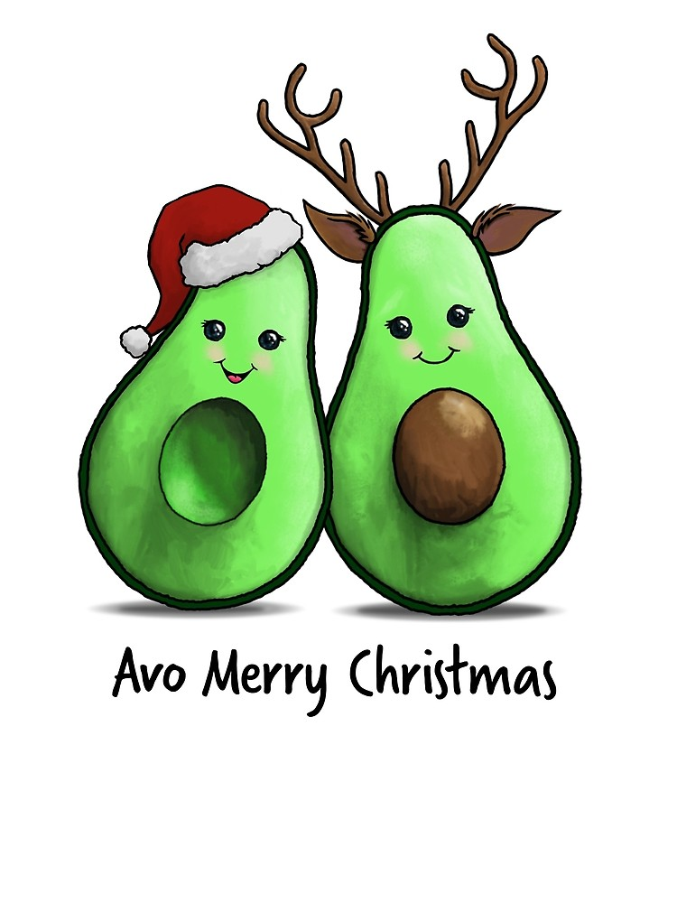

Cold Buffet

Salad Bar

Potato, bacon and pea **GF**

Pecan, avocado and maple **GF, V**

Caesar salad

Grilled bean and asparagus **GF, V**

Antipasto

Assorted cold meats

Semi dried

Roasted capsicums

Kalamatta olives

Pesto cheese

Marinated feta

Chorizo

Seafood

South Australian oysters

North West prawns

Cocktail sauce

Lemons

**Adults $120pp**

**Senior Card holders $40pp**

**Children under 12 $35pp**

Hot Buffet

Turkey roll with glazed ham **GF**

Pan seared barramundi with lemon butter **GF**

Roasted sirloin with seeded mustard jus

Crispy pork belly **GF**

Roasted vegetables **GF, V**

Potato gratin **GF, V**

Dessert Buffet

Bread and butter pudding

Cakes and slices

Scones with jam and cream

Mini Pavlovas

Crème caramels

Cream dollops

Tea and coffee station

**GF – Gluten Free**

**V – Vegetarian**